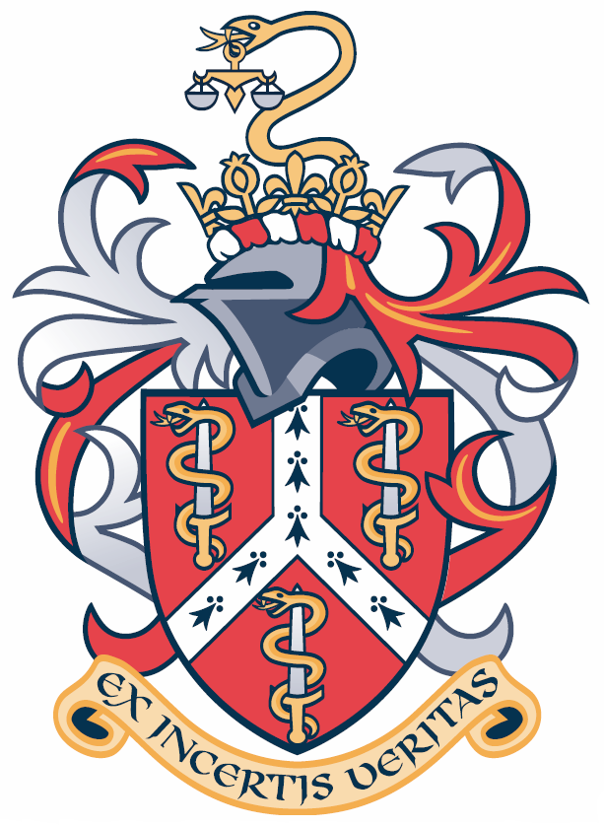
FFLM Development Training Day
Child Safeguarding, Sat 24 October 2015
Royal College of Physicians, Regents Park, London NW1 4LE

Please complete in BLOCK CAPITALS & return no later than Friday 16th October 2015.

Title: Forename: Surname:
(Please write you name as you would like it to appear on your delegate badge, BLOCK CAPITALS PLEASE)
Job Title: | Location:
FFLM Membership Type: Fellow / Member / Licentiate / Affiliate / Associate / Non-member (please circle)
Type: Forensic Practitioner / MLA / Medical Coroner / Pathologist / SOE / Other (please circle)
Daytime contact no: Mobile no:
Email:
Correspondence Address:
Post Code:
Dietary requirements:
Ticket Option |  | Cost | Quantity | TOTAL
FFLM membership  (FFLM Fellows, Members, Licentiates / Affiliates / Associates) |  | £150
Non-member |  | £200
Block Booking
A 20% discount is available to overall fees for any booking exceeding 20 persons (please contact the Registrar for further details)
 |  |  | FINAL TOTAL

Booking Terms & Cancellation Policy
- Places on the course will be allocated on a first-come, first-served basis.
- You will be sent a receipt by email confirming your booking/ payment, if you do not receive this please contact the office.
- The closing date for receipt of payment and booking forms is Friday 16th October 2015. However the course may fill up before this date so please book early to avoid disappointment.
- Notification of cancellation received in writing by Friday 16th October 2015will entitle the delegate to a refund of pre-paid fees less an administration charge of 50% of fees.

No refund will be given after Friday 16th October 2015.

Method of Payment
- A cheque made payable to “FACULTY OF FORENSIC & LEGAL MEDICINE”
- For bank transfer please contact forensic.medicine@fflm.ac.uk for account details.
Please sign to confirm your acceptance of this booking and the terms stated above.

Signed: Date:

What to do now
Please arrange payment and return your booking form to forensic.medicine@fflm.ac.uk or to the address below to reserve your place:
Conference Bookings, FFLM

Suite 416, 1 Alie Street, London, E1 8DE

